MODEL ENGINEERING COLLEGE, THRIKKAKARA

DEPARTMENT OF COMPUTER ENGINEERING



RECORD OF PRACTICAL WORKS

OOP CST205

CLASS: CS 3 B (2019 Ad.)

Name of Student: ADITHYA A

Roll No: 03

EXP No.: 01

Second Smallest Number

AIM

Program to find the second smallest number in an array in java.

PROGRAM

public class Main{

public static int funcSecondSmallest(int[] arr, int num){

int temp;

for (int i = 0; i < num; i++)

{

if (arr[i] > arr[i+1])

{

temp = arr[i];

arr[i] = arr[i+1];

arr[i+1] = temp;

}

}

return arr[1];

}

public static void main(String args[]){

int a[]={35,4,7,1,22,54,62,80}, i;

System.out.print("The given array is:");

for (i = 0; i < 7; i++)

{

System.out.print("\t" + a[i]);

}

System.out.println("\n The second smallest number is: " + funcSecondSmallest(a,7));

}}

OUTPUT

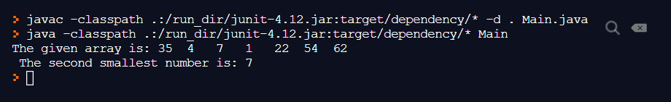

EXP No.: 02

Prime Number

AIM

Program in java to check whether a number is prime or not.

PROGRAM

public class Main {

public static void main(String[] args) {

int num = 13;

boolean b = false;

for(int i = 2; i <= num/2; ++i)

{

if(num % i == 0)

{

b = true;

break;

}

}

if (!b)

System.out.println(num + " is a prime number.");

else

System.out.println(num + " is not a prime number.");

}

}

OUTPUT

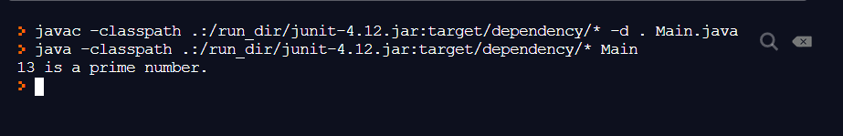

EXP No.: 03

Function Overloading

AIM

Program to Illustrate the function overloading in Java

PROGRAM

class func_overload

{

void area(float x, float y)

{

System.out.println("the area of the rectangle is "+ x * y +" sq units");

}

void area(float x, float y, float z)

{ double s = (x+y+z)/2;

double triangle;

double a = (s*(s-x)*(s-y)*(s-z));

triangle = Math.sqrt(a);

System.out.println("the area of the triangle is:" + triangle + "sq.units");

}

void area(double x)

{

double z = 3.14 * x * x;

System.out.println("the area of the circle is "+ z + " sq units");

}

}

public class Main

{

public static void main(String args[])

{ func_overload object = new func_overload();

object.area(3, 4, 5);

object.area(52, 14);

object.area(5);

}

}

OUTPUT